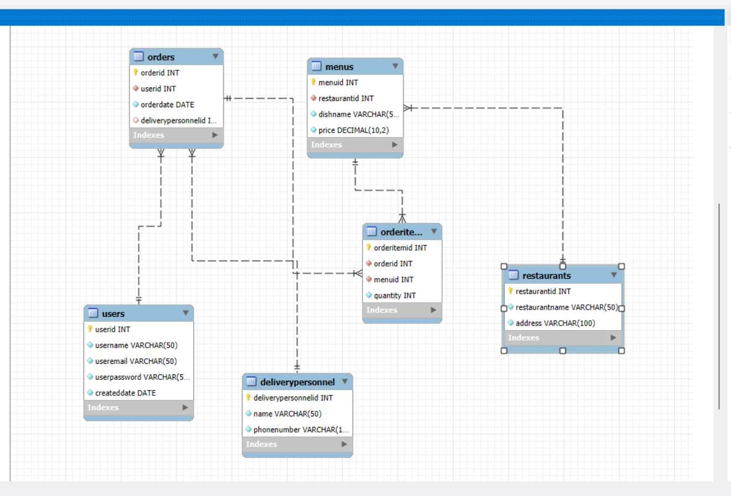

This is food delivery database, in this I have add 6 tables.

6 Tables are,

1.User table

2.Restaurant table

3.Menus table

4.Delivery personnel table

5.Orders table

6.Order items table

1.User table:

Here I add user details like user id, user name, user mail, user password. And also I use user id as primary key for unique identity of the user.



2.Restaurants table:

In this I add restaurant details like restaurant id, restaurant Name, restaurant address. And also I use restaurant id as primary key for unique identity.

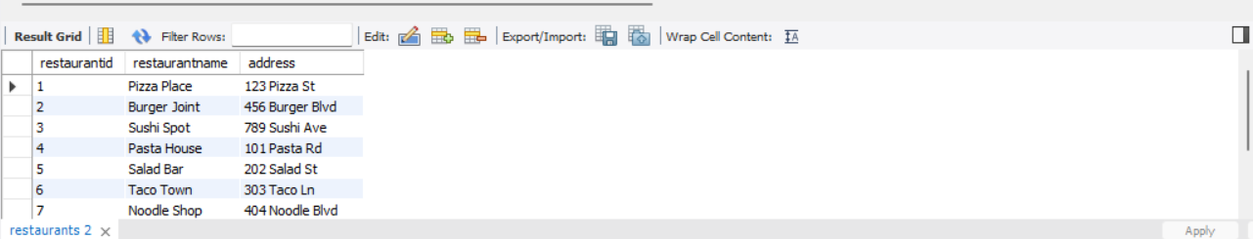

3.Menus table:

In this add details about the menu like Menu id, Menu name, menu price. And I have add menu id as primary key for unique identity and restaurant id as foreign key to connect the menu table with restaurant table.



4.Delivery personnel table:

Here I add details about person’s detail like delivery personnel id, person name and phone number.

And I use delivery personnel id as primary key for unique identity of the person.



5.Orders table:

Here I add details about orders like order id, order date. And here order id as primary key for unique identity of order then user id, delivery personnel id as foreign key to join the order table with delivery personnel table.

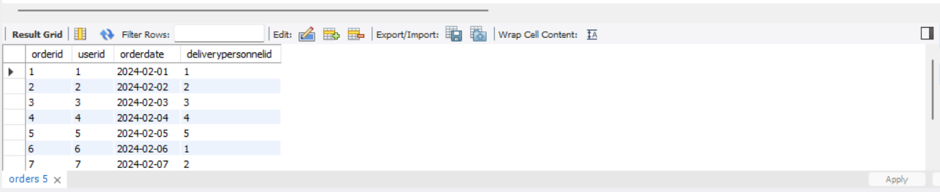

6.Order items table:

Here I add details about items detail like order item id and quantity of the item. And I have add order item id as primary key then order id and menu id as foreign kay to connect the order table with this reference.

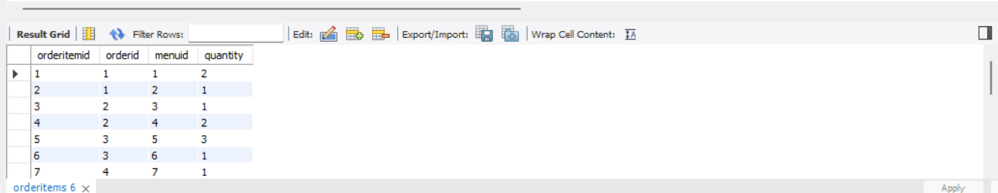

Over all connection of all tables:

